Classifying melanoma images using mobile camera and Machine Learning

Yash Mhatre

(Student ID: 19063196)

October 2019

1. **Overview and Presentation**

Artificial Intelligence is a massive field in which the applications of machine learning are used. Image Detection, Classification, and Recognition are some aspects coved under Machine learning. While these three branches seem to almost similar, each of them has only one goal – improving AI’s abilities to detect visual content. (Azati, 2019)

The term ‘Image classification’ could be defined as a task of accrediting an input image with one of the labels from a fixed set of categories. Despite its simplicity, it is considered as one of the most important problems in Computer Science it does have a huge variety of practical aspects. (Sagar, 2019)

Arthur Samuel, an IBM developer was the first to coin the term ‘Machine Learning’ in the 1950s (Foote, 2019) which sparked interest in numerous developers around the globe ever since. Google CEO rightfully said “AI is one of the most important things humanity is working on. It is more profound than, I don’t know - electricity or fire.”

While most of the leading researches focused on model training with various neural networks(Brinker et al., 2019; Fujisawa, Inoue, & Nakamura, 2019; Guo, Ashour, Si, & Mandalaywala, 2019; Pérez-Ortiz, Sáez, Sánchez-Monedero, Gutiérrez, & Hervás-Martínez, 2016; Sachdev, Shekhar, & Indu, 2018; Shihadeh, Ansari, & Ozunfunmi, 2019), only (Dai, Spasić, Meyer, Chapman, & Andres, 2019) specified use of lighters models so as to run them on the mobile systems.

Similar to (Dai et al., 2019), this research aims to provide a robust application that would run on the local device without needing to send personal medical data on the cloud. A prototype of an android based application that would provide a visual classification of melanoma and non-melanoma images is developed. Devised by the Google Brain team, TensorFlow is an open source library used for numerical computation and large-scale machine learning. It’s a bundle of algorithms, neural networking models and machine. The framework uses Python providing users with a comfortable back-end API for building applications. (Yegulalp, 2019)

1. **System Artefacts**

As specified in the 1st milestone document, the project development would be divided into 2 artefacts: Model building and Mobile application building. Also, this application would depend more on the trained model and the accuracy of the output as compared to the UI aspect as providing accurate classification is more important when dealing with sensitive medical data.

* 1. **Model building:** Tensorflow – a Javascript framework developed by google, allows the developers to create data-flow graphs which are basically structures describing the movement of data in a series of processed nodes. Each node in these graphs represent a mathematical operation while every connection between these nodes is a multidimensional data array otherwise known as ‘tensor’. (Yegulalp, 2019) While tensorflow is developed in association with python, most of its mathematical calculations are redirected from complex C++ binaries.

The concept of transfer learning is applied for the app creation. Mobilenet v.1.0_224 – a pretrained model for image classification was retrained by administering it with desired images. The benefit of such a model is that it provides a steady accuracy for the output values. It not only provides with accurate outputs, but also with compact model which consumes minimal space.

As it is established that the machine learning model which is generated is usually very heavy in terms of space and consumes a lot of computation capacity. The application which is delivered, is not only light-weight but also computationally friendly. Also, as mentioned in milestone 1, the application would be able to run locally without interference of any cloud components, due to privacy concerns regarding sharing of personal medical data, in this case diseased skin images. Training aid from Google’s CodeLab developers and various YouTube tutorials were rendered very useful.

Resultant model was generated in a (.pb) file. To reduce the model’s size further so as to fit it in a mobile device, it is converted in either (.lite) or (.tflite) file.

* 1. **Mobile App building:** For distribution purposes, the built model must have an interactive approach. As mentioned in the earlier assignment, the application development would be carried out on a Native coding system. This application is designed on Android, using Android studio 3.5.1. The application runs on a very basic UI which not only classifies the skin legion into melanoma or non-melanoma but also provides a confidence score. *(Figure 1)*

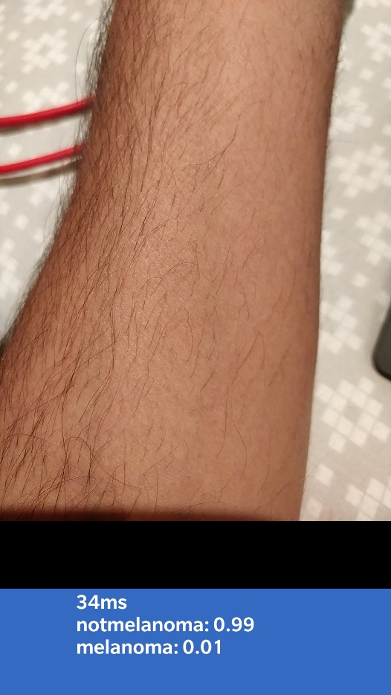

*Figure 1: A visual of the application’s Screen*

1. **System Evaluation**

System was evaluated by mean of the concept called “Unit Testing”. Unit Testing is a software development process where the system is broken down into smallest testable parts and are independently check for their proper working. The main objective of unit testing is to isolate written code to test and determine if it works as intended.

Benefits of unit testing: (Automate, 2018)

* Proves the working of code
* Low-level regression-test suite
* Improve the design without breaking it
* In form of sample code
* Reduces the cost of bug-fixing
* Can improve the app’s design

1. **Recommendations**
   1. **Strengths & Limitations**

As repeatedly mentioned, due to privacy the application must remain on the local system, thus, the raw design of the application although provides privacy in detection of melanoma, because of it runs real time, it’s difficult to record the outputs. Another drawback of the application would be to save the obtained outputs.

* 1. **Future Aspects.**

An even better and interactive User-interface needs to be administered for this application. Buttons to provide images from the gallery and/or save the outputs could be entered. Addition of sending patient data to the doctors could also be added. Suggestions based on the type of melanoma being detected could be a plus to the system. Also, instead of using the concept of transfer learning, the model used could be built from scratch.

**References**

Automate. (2018, December 11). Unit Testing Guidelines What to Test And What Not. Retrieved October 30, 2019, from https://www.automatetheplanet.com/unit-testing-guidelines/.

Foote, K. D. (2019, March 13). A Brief History of Machine Learning. Retrieved October 30, 2019, from https://www.dataversity.net/a-brief-history-of-machine-learning/#.

Image Detection, Recognition, and Classification with Machine Learning. (2019, May 16). Retrieved October 30, 2019, from https://azati.ai/image-detection-recognition-and-classification-with-machine-learning/.

Sagar, A. (2019, October 7). Deep Learning for Image Classification with Less Data. Retrieved October 30, 2019, from https://towardsdatascience.com/deep-learning-for-image-classification-with-less-data-90e5df0a7b8e.

Yegulalp, S. (2019, June 18). What is TensorFlow? The machine learning library explained. Retrieved October 30, 2019, from https://www.infoworld.com/article/3278008/what-is-tensorflow-the-machine-learning-library-explained.html.

Brinker, T. J., Hekler, A., Enk, A. H., Klode, J., Hauschild, A., Berking, C., … Schrüfer, P. (2019). Deep learning outperformed 136 of 157 dermatologists in a head-to-head dermoscopic melanoma image classification task. *European Journal of Cancer*, *113*, 47–54. https://doi.org/10.1016/j.ejca.2019.04.001

Dai, X., Spasić, I., Meyer, B., Chapman, S., & Andres, F. (2019). *Machine Learning on Mobile: An On-device Inference App for Skin Cancer Detection*. 301–305. https://doi.org/10.1109/FMEC.2019.8795362

Fujisawa, Y., Inoue, S., & Nakamura, Y. (2019). The Possibility of Deep Learning-Based, Computer-Aided Skin Tumor Classifiers. *Frontiers in Medicine*, *6*(August). https://doi.org/10.3389/fmed.2019.00191

Guo, Y., Ashour, A. S., Si, L., & Mandalaywala, D. P. (2019). Multiple Convolutional Neural Network for Skin Dermoscopic Image Classification. *2018 IEEE International Symposium on Signal Processing and Information Technology, ISSPIT 2018*, 365–369. https://doi.org/10.1109/ISSPIT.2018.8642669

Pérez-Ortiz, M., Sáez, A., Sánchez-Monedero, J., Gutiérrez, P. A., & Hervás-Martínez, C. (2016). Tackling the ordinal and imbalance nature of a melanoma image classification problem. *Proceedings of the International Joint Conference on Neural Networks*, *2016*-*Octob*, 2156–2163. https://doi.org/10.1109/IJCNN.2016.7727466

Sachdev, J., Shekhar, S., & Indu, S. (2018). Melanoma Screening Using Deep Neural Networks. *2018 3rd International Conference for Convergence in Technology, I2CT 2018*, 1–5. https://doi.org/10.1109/I2CT.2018.8529724

Shihadeh, J., Ansari, A., & Ozunfunmi, T. (2019). Deep Learning Based Image Classification for Remote Medical Diagnosis. *GHTC 2018 - IEEE Global Humanitarian Technology Conference, Proceedings*. https://doi.org/10.1109/GHTC.2018.8601558